**MongoDB CRUD Operations**

Create database **“wishtree_data”** & collection **“employee”** :-



Show collections :-



Insert records using insert() & insertMany() :-

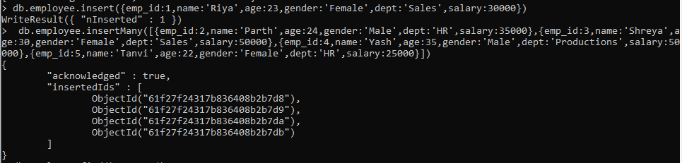

Show Records :-

Using find() :-

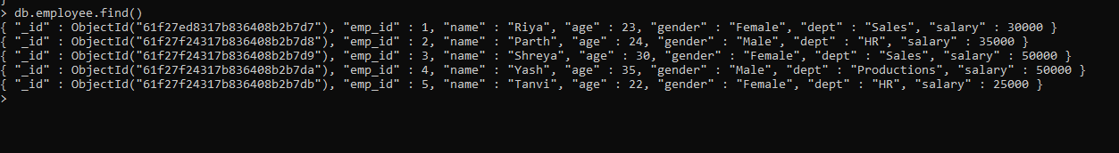

Using findOne() :-

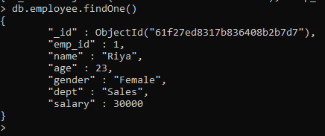

Using pretty() :-

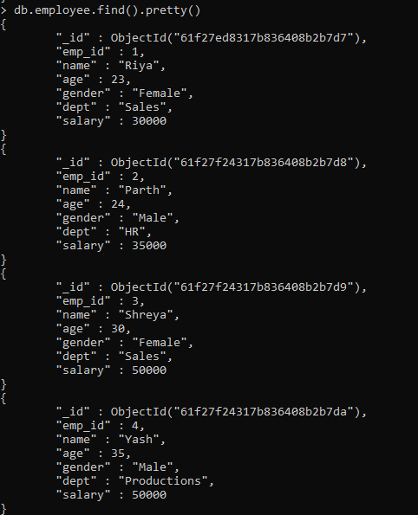

Using limit() :-

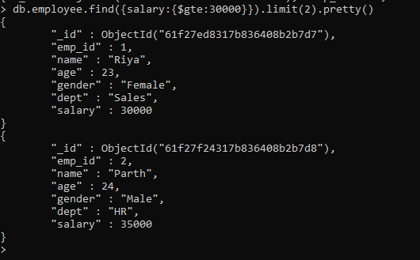

Using $ne :-

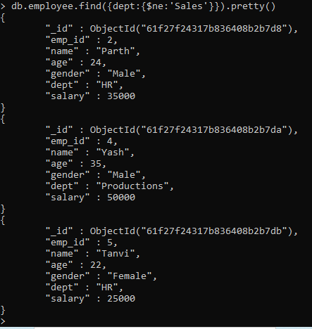

Using skip() & limit() :-

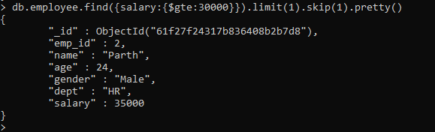

Using projection & sort() :-

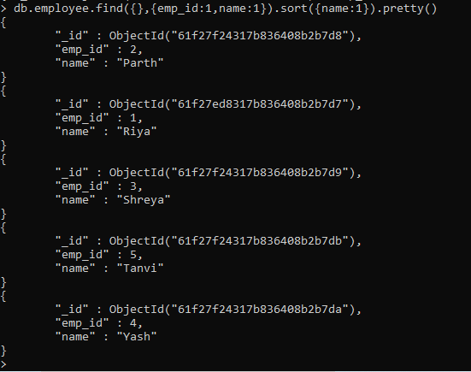

UpdateOne() :-



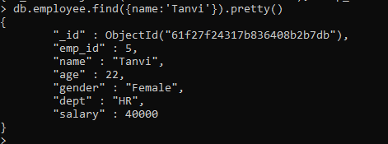

DeleteOne() :-



Count all documents :-



Remove specific documents :-

